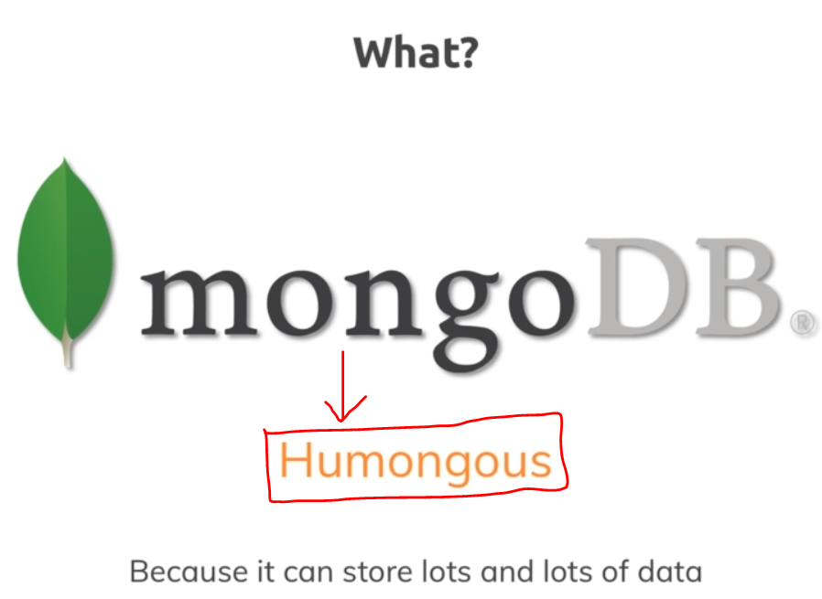

Mongo-db data-base is used to store lots and lots of data and not just from a data-size perspective but also in a sense of you can store lots of data and you can work with it efficiently.

Mongo-db is a data-base solution. We got post-gress, mysql etc.  
But how mongo-db is different from other data-base solutions???  
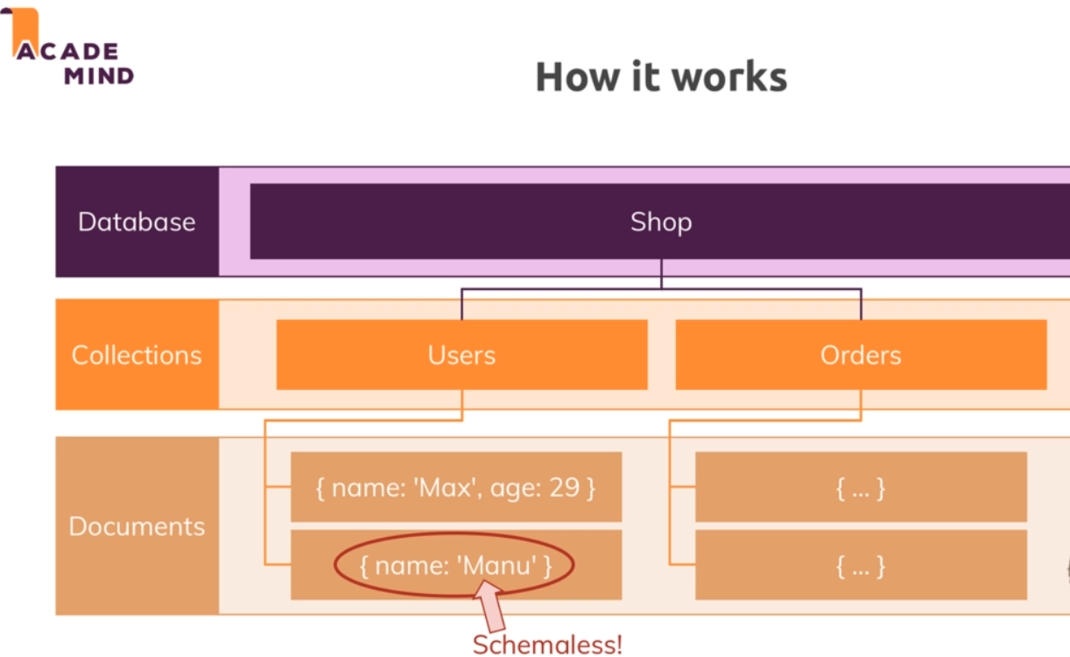

Mongo-db is a data-base server that allows you to run different-different data-bases on it.

My-sql 🡪 Tables   
Mongo-db 🡪 collections

My-sql 🡪 Attributes/Column name  
Mongo-db 🡪 Documents

Inside the document, it is schema less.  
Eg: There is no age data in the second document   
My-sql 🡪 not accepted  
mongo-db 🡪 will be accepted

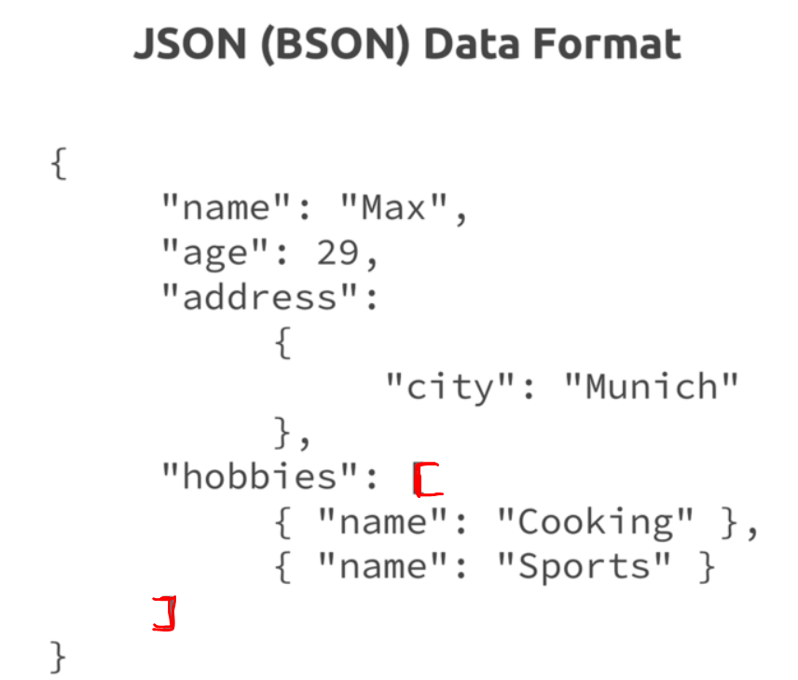

This al-together is one document inside a collection.  
Mongo-db converts the JSON data to the binary version which can basically be stored and can be queried more efficiently.

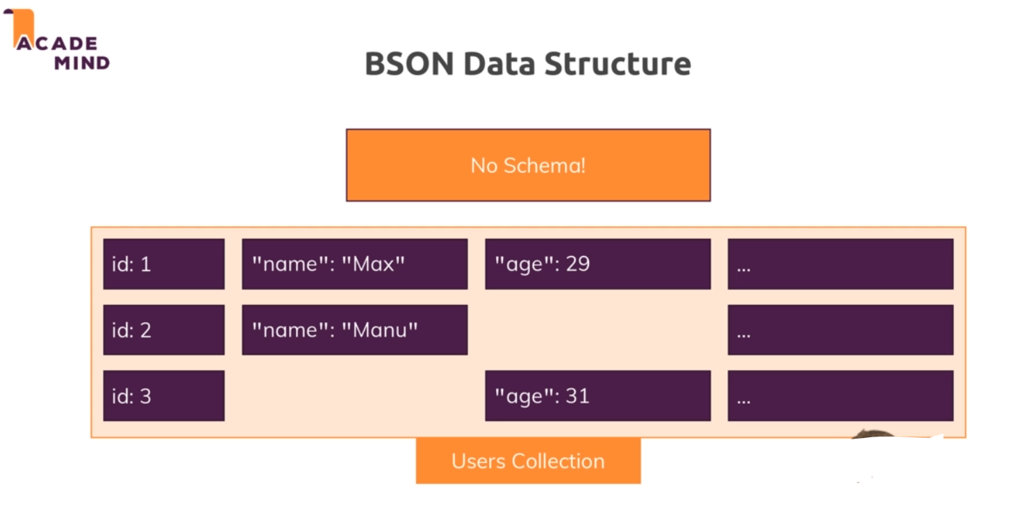

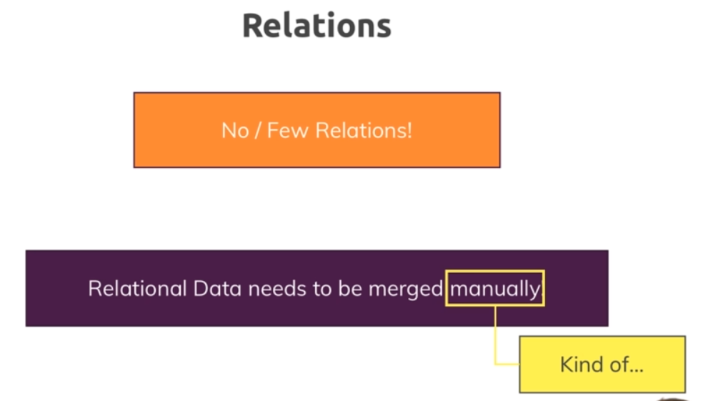  
**Mongo-DB Ecosystem**

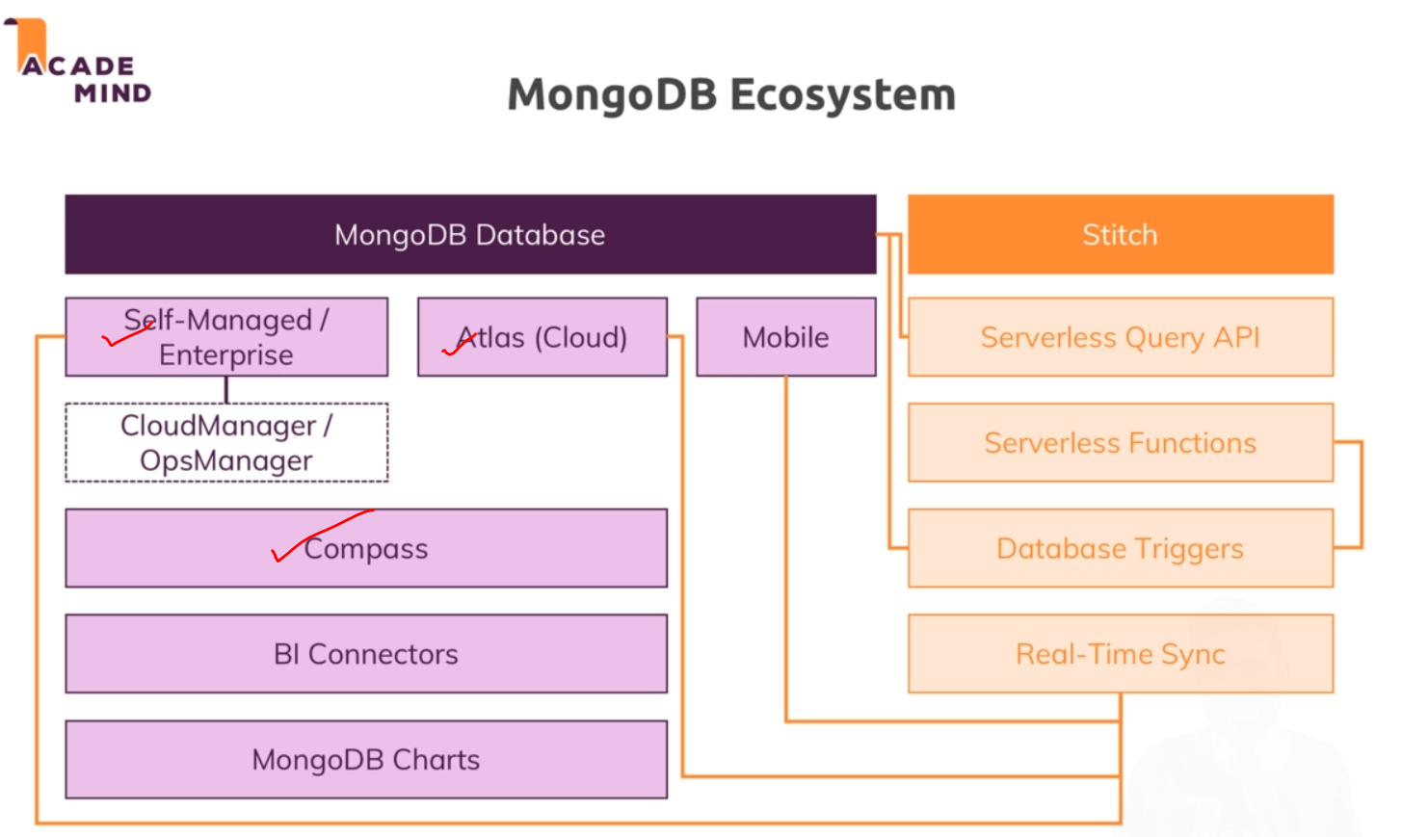

# **Time to get started**

Initially connecting to the mongo-db server.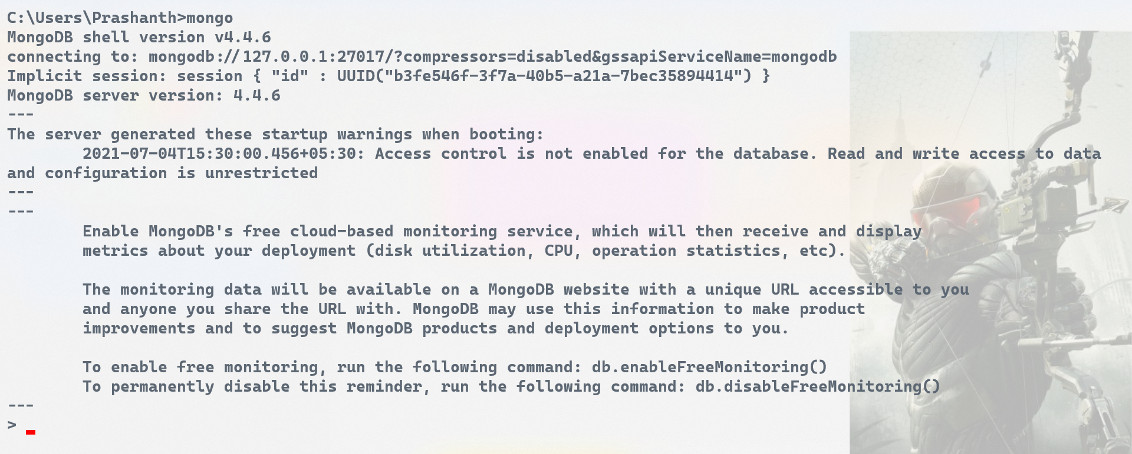

To see what are all the data-bases available in our system  
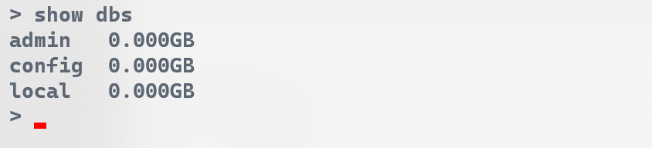

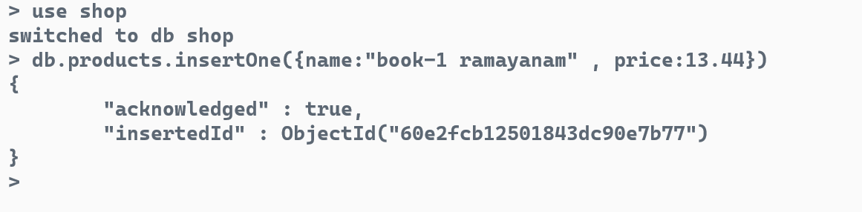

Shop 🡪 data-base (uses if exists/creates a new one)  
products 🡪 collections/tables

.insertOne() 🡪 will insert the documents/records into the collections  
The below message is the acknowledgement for the inserted data.

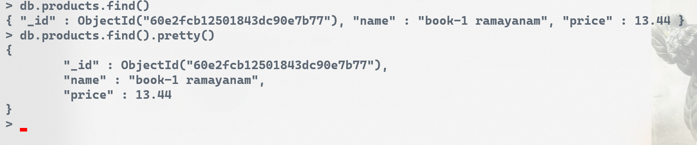

**db.products.find()** 🡪 The **find()** method with no parameters returns all documents from a collection and returns all fields for the documents  
**db.products.find().pretty()** 🡪 pretty() method is used mainly to display the result in a more easy-to-read format.

Adding one more field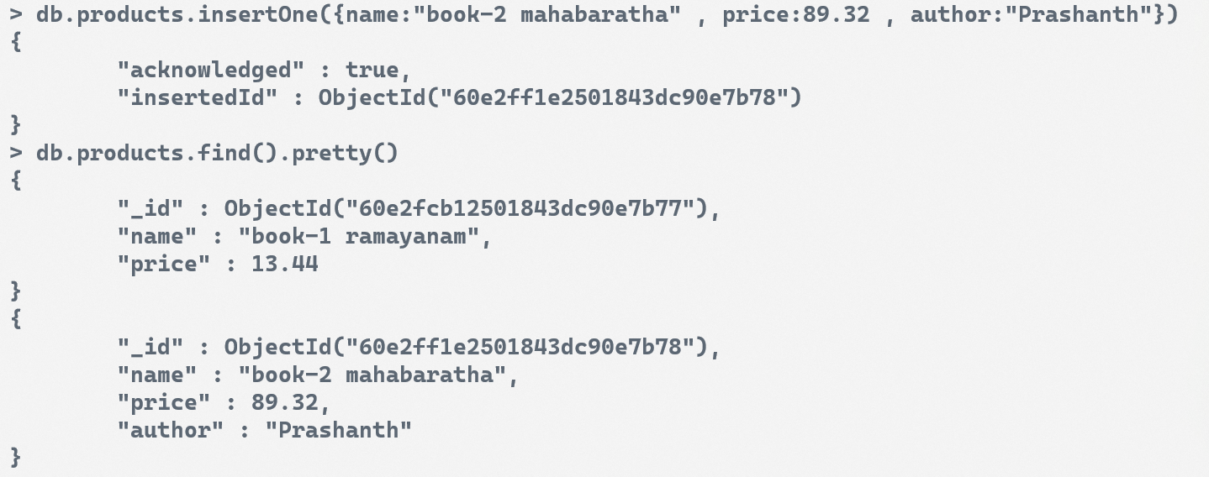

**Adding more collections (i.e nested collections)**

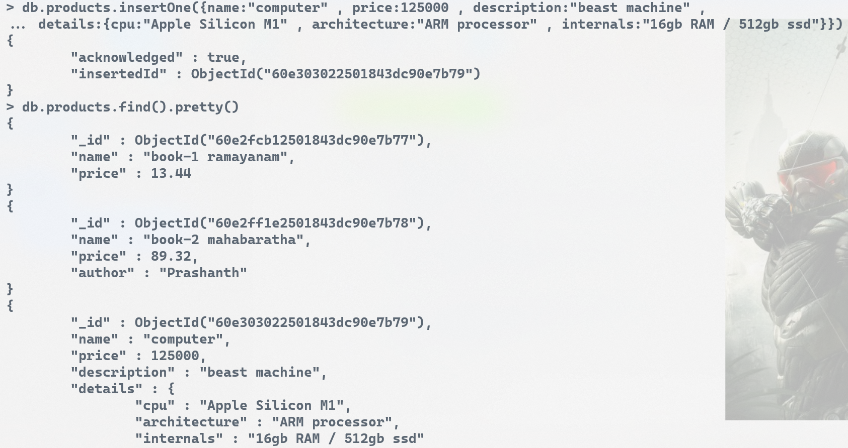  


# **Course Outline**

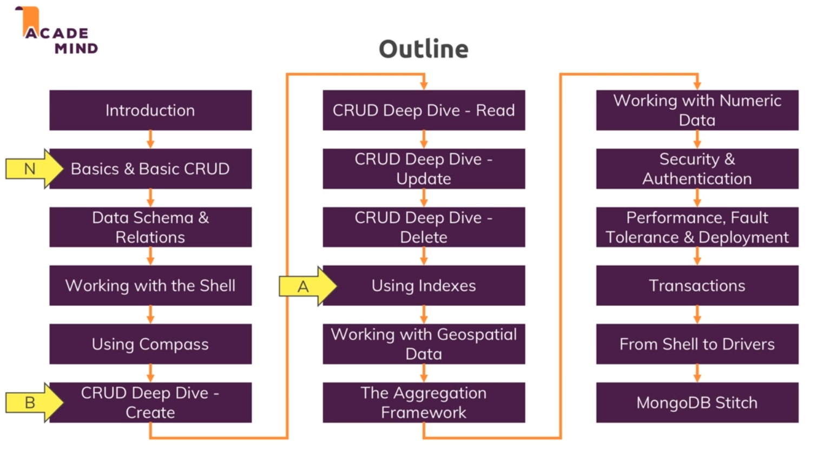

# **Shell vs Drivers**

Shell 🡪 native ground for all the platforms independent of the programming language used.   
Drivers 🡪 specific for a programming language. Python,JAVA,C etc.. can able to communicate to the mongo-db servers by using their respective drivers.

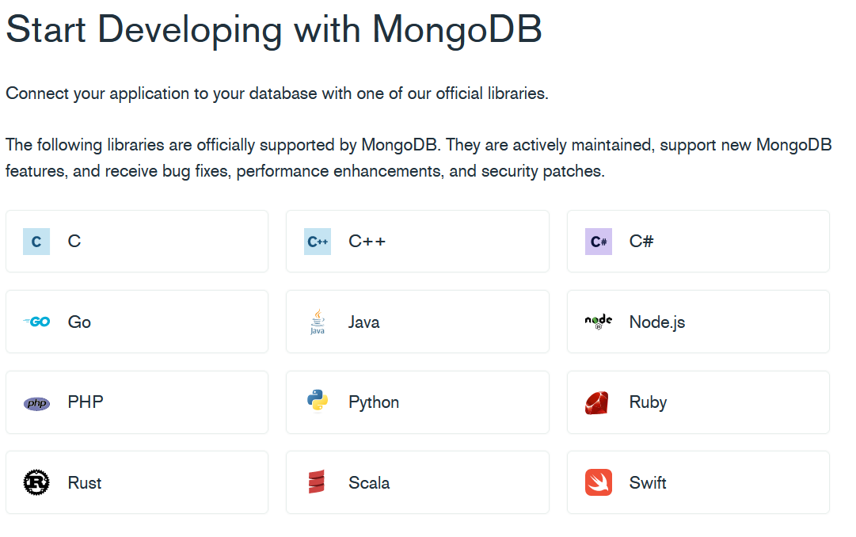

These are the different drivers available in mongo-db.

## **Python 🡪 PyMongo Driver**

## **JAVA 🡪 Java MongoDB Driver**

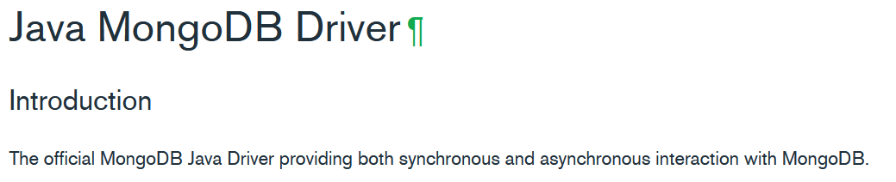

## **C language 🡪 MongoDB C Driver**

